CPSO Notes/Resources for Future Students Applying for Internship

- Internship Credits
  - Sign up for 1 credit (EDPS 959) for both Fall and Spring semester while on internship
  - Eva Bachman was able to allow out-of-state residents to earn in-state tuition for the credits this year and hopefully this will continue to be allowed the following years. This saved us quite a bit of money given the large difference between in-state versus out of state credit. Contact Eva ebachman1@unl.edu or Hollie hswanson5@unl.edu
  - In order to be in our program, you must be considered full-time. Therefore, when you are taking less than a full-time load, you can complete the full-time graduate student certification every semester you drop below the credits necessary to be considered a full-time graduate student (you can do this for a total of 4 semesters). You must fill this out every semester and your advisor must approve it.
    - This is essential for financial aid purposes if you want to be eligible for loans you must be considered full-time
    - See link for more details-- http://www.unl.edu/gradstudies/bulletin/registration/reqs
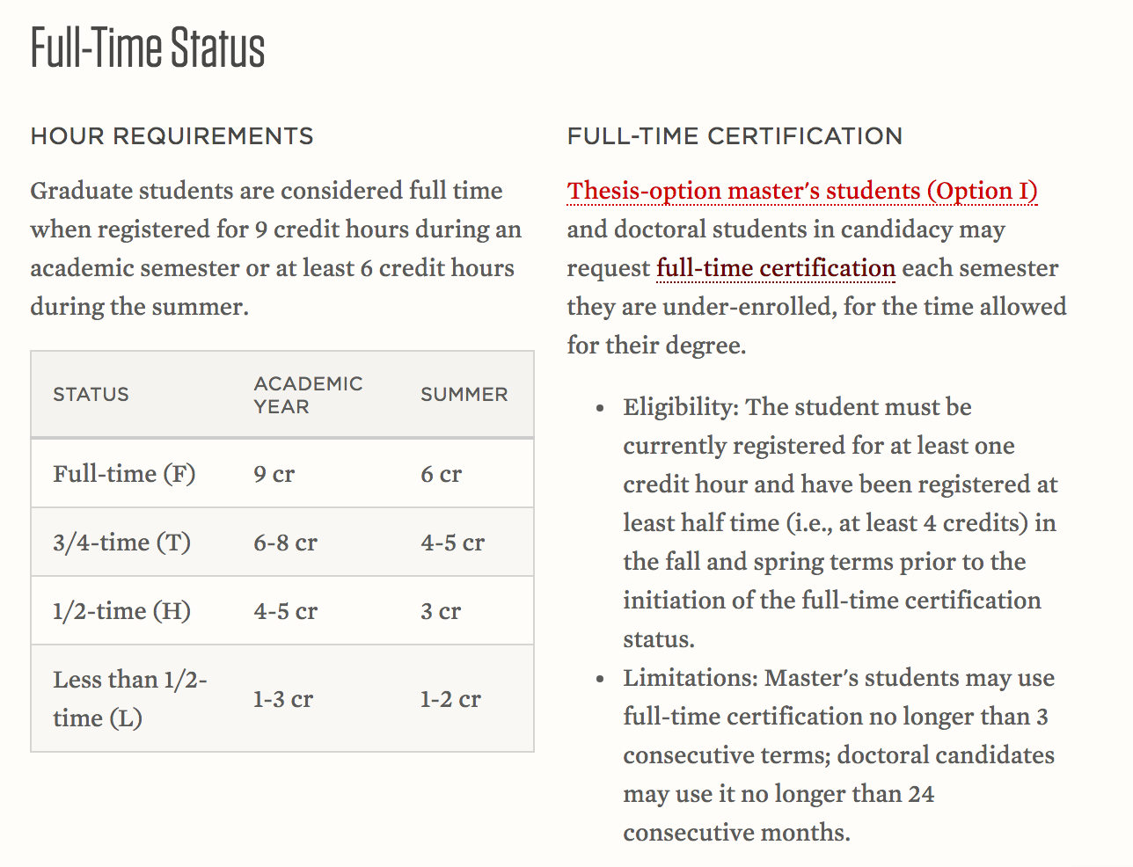

- While on internship you can obtain a University Program and Facilities Fee waiver since you are no longer using the UNL resources
  - Contact Stan Campell at scampbell1@unl.ed
    - “I am able to grant a waiver for each semester of your internship provided your advisor verifies the out of state internship is a degree requirement. However, I will need that verification for each semester.” -Stan Campbell

- Surpassing 140 credit limit and federal financial aid.
  - This specifically applies to post-bachelor’s doctoral students as the Counseling Psychology program requires more than 140 credits to complete the degree.
  - Below is a screenshot of an email obtained from Scholarships and Financial Aid once I hit 140 credits - Jess Tate
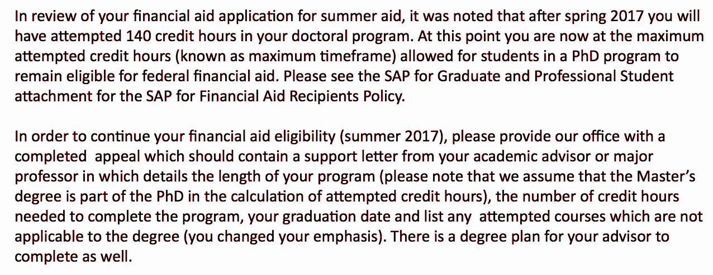
  - Many interns use federal financial aid (loans) to supplement the cost of relocating for internship, coupled with low salaries at some internship sites, among many other additional costs. If you would like to be eligible for federal financial aid once you reach 140 credits you will need to complete the Satisfactory Academic Progress (SAP) form, write a letter explaining your reason for the appeal, and have your advisor indicate that the Counseling Psych program requires more than 140 credits for completion. Your application will go to a review board and they will decide if they will re-instate you for federal financial aid. If they re-instate you then you will be eligible to obtain aid.

4. If your internship completion date falls after the August graduation date, be sure to contact the training director of our program and your new internship training director to discuss this matter. Typically, you can still graduate if you get a letter from your internship training director saying you are making adequate progress toward the completion of your internship experience.

